**Lab 09a - Implement Web Apps**

**Mihail Elencevski**

#### Task 1: Create an Azure web app

In this task, I am creating an Azure web app using the Azure portal. I am specifying various settings, such as the resource group, web app name, runtime stack, and operating system, and then deploy the web app.

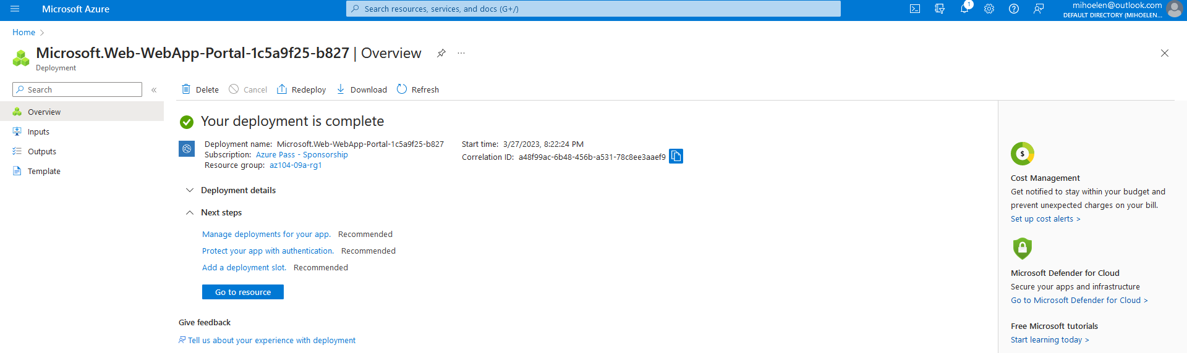

#### Task 2: Create a staging deployment slot

In this scenario I am creating a staging deployment slot for the Azure web app that I created in the previous task. Accessing the web app's default web page, create a new deployment slot, and configure its settings. Then I am reviewing the properties of the new staging slot and **observe that its URL is different from the production slot's URL.**

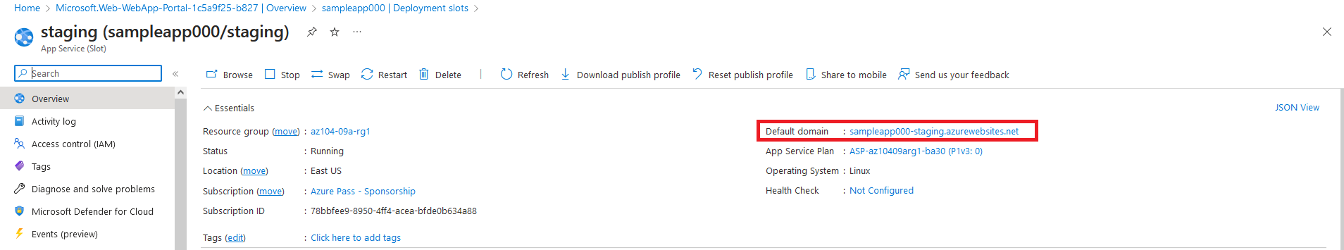

#### Task 3: Configure web app deployment settings

In this scenario I am confiquring the deployment settings for the staging deployment slot of the Azure web app. Then selecting **Local Git** as the source, saving the changes, and set up **Local Git/FTPS** credentials by specifying a unique user name and password that satisfies complexity requirements.

In the picture bellow iam proving that I successfully created Deployment Provider and Username.

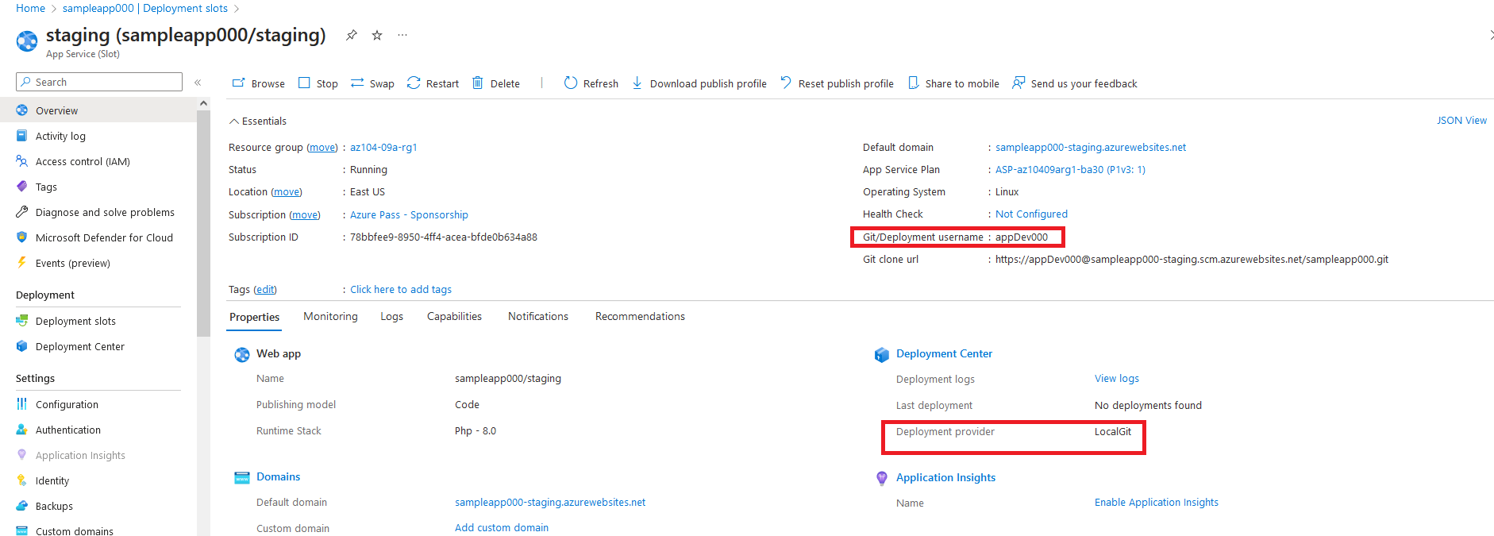

#### Task 4: Deploy code to the staging deployment slot

In Task 4, I am deploying code to the staging deployment slot using Azure Cloud Shell. Then I am instructed to clone a remote repository containing the code for the web app and then set the current location to the newly created clone. Further, I am asked to add the remote git and push the sample web app code from the local repository to the Azure web app staging deployment slot. Finally, I am verifying the deployment by checking if the **default web page** displays the Hello World! message.

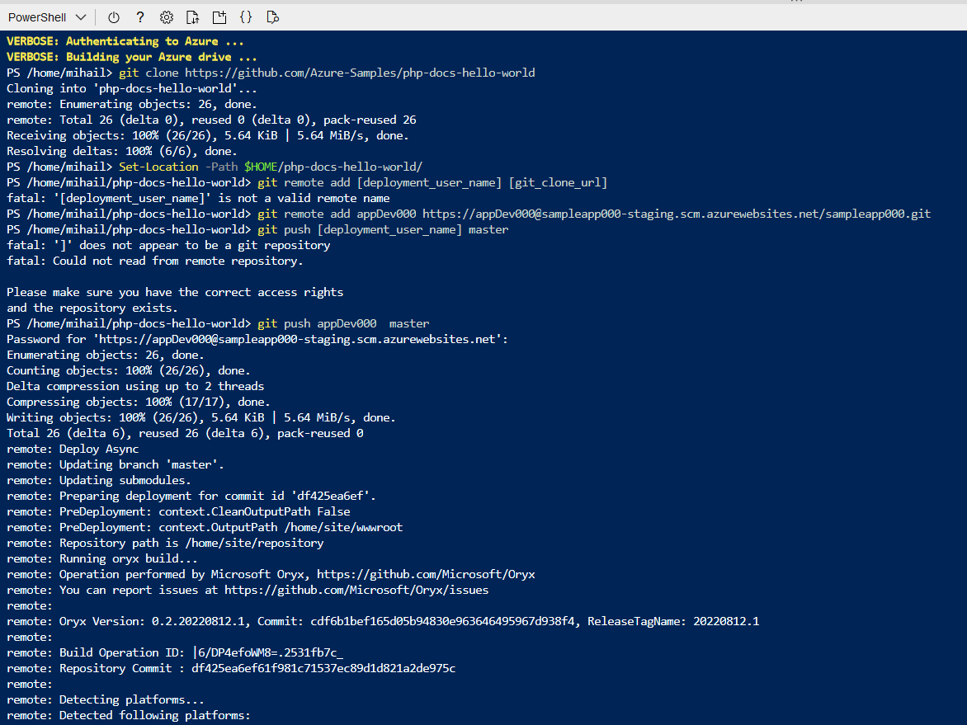

This is the picture where I am proving the default web page displays the **Hello World message.**

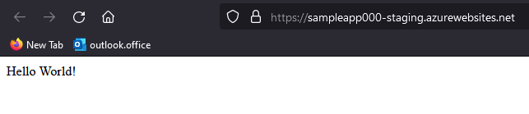

#### Task 5: Swap the staging slots

Here I am swaping from staging slot to production slot.

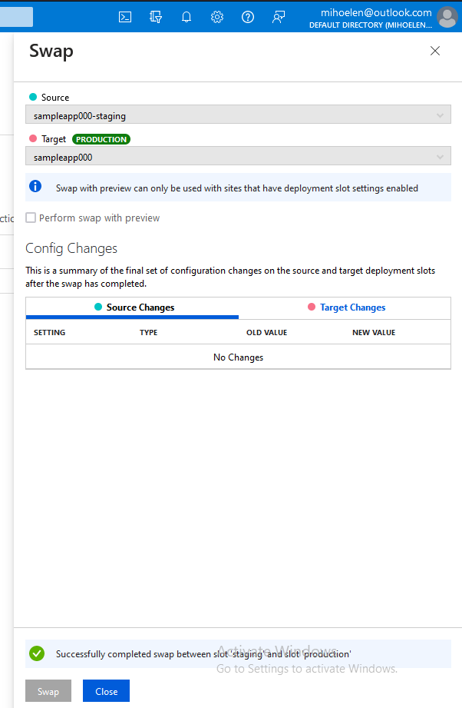

The default web page now has been replaced with the **Hello World!** page.



#### Task 6: Configure and test autoscaling of the Azure web app

In thi task, I need to configure and test **autoscaling** of an Azure web app. This involves setting up custom autoscale rules based on CPU percentage, specifying instance limits, and monitoring the observed resource instance count. An infinite loop is used to send **HTTP requests** to the web app and **the number of instances** is monitored until it increases to the maximum specified in the autoscale rules.

**The picture bellow proves that instances increase to 2.**

